ContactManagement_Verify Contact notes _Instance44_13-Jul-2018_03-36-09_AM_MouseClickActiononStaleElement.png



ContactManagement_Verify Contact notes _Instance44_13-Jul-2018_03-36-06_AM_MouseClickActiononStaleElement.png



ContactManagement_Verify Contact notes _Instance44_13-Jul-2018_03-38-08_AM_VerifyingAllNotesofanindividual.png

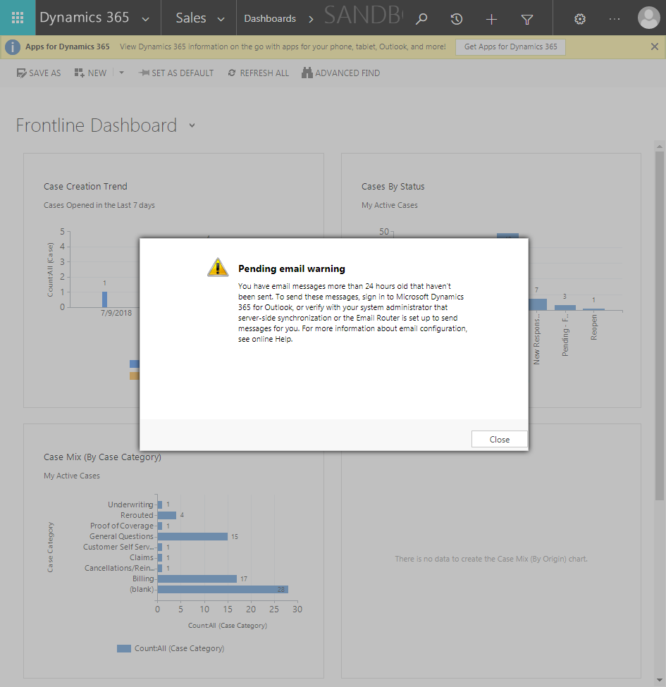

ContactManagement_Verify Contact notes _Instance44_13-Jul-2018_03-37-50_AM_VerifyingLatestNotesofanindividual.png

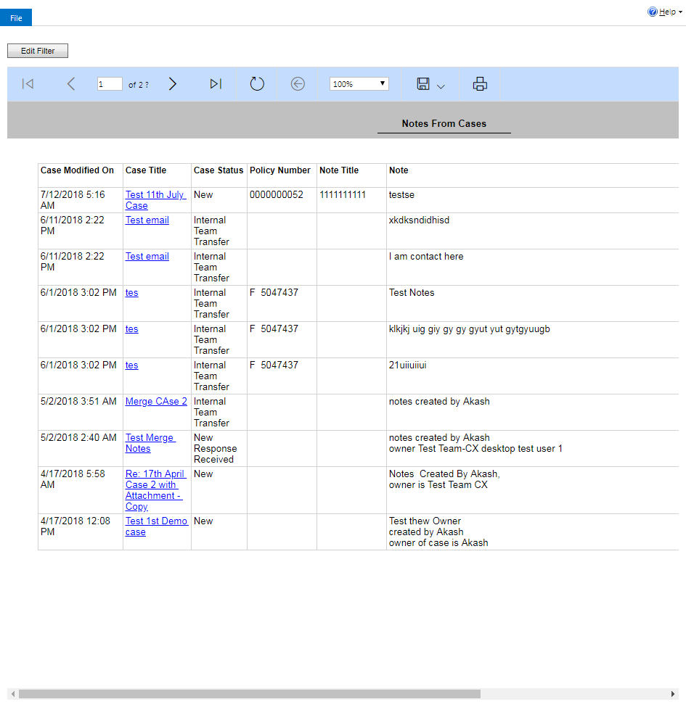

ContactManagement_Verify Contact notes _Instance44_13-Jul-2018_03-38-07_AM_SingleSignOn.png

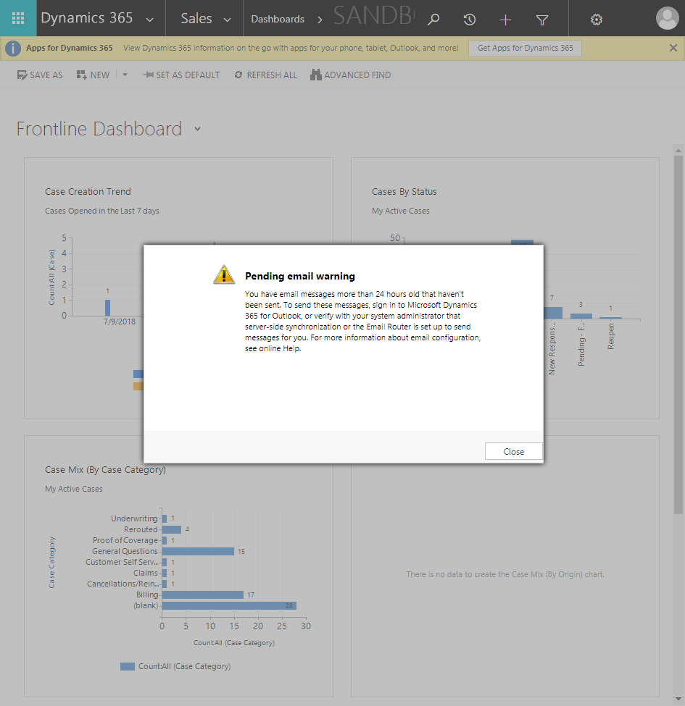

ContactManagement_Verify Contact notes _Instance44_13-Jul-2018_03-38-02_AM_VerifyingAllNotesofanindividual.png

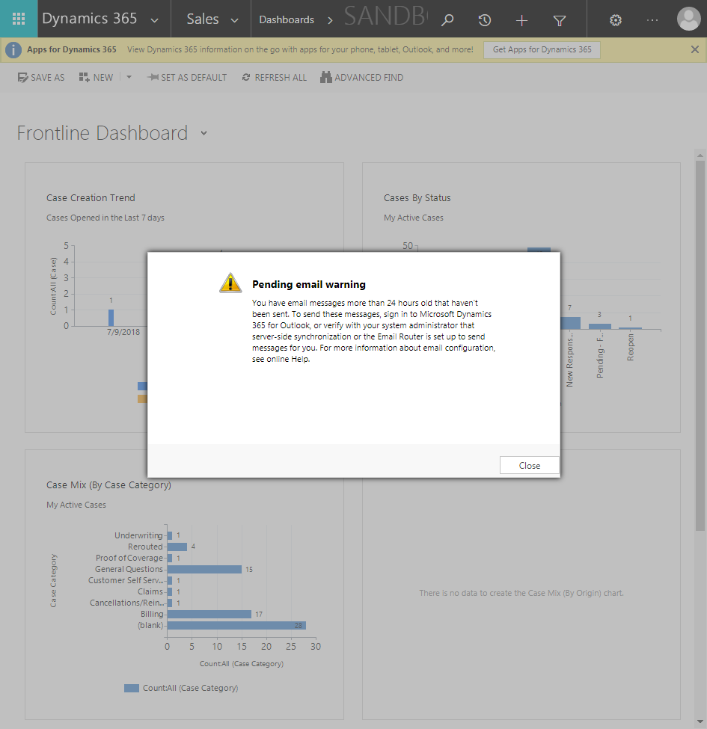

ContactManagement_Verify Contact notes _Instance44_13-Jul-2018_03-37-52_AM_VerifyingAllNotesofanindividual.png



ContactManagement_Verify Contact notes _Instance44_13-Jul-2018_03-36-24_AM_SingleSignOn.png

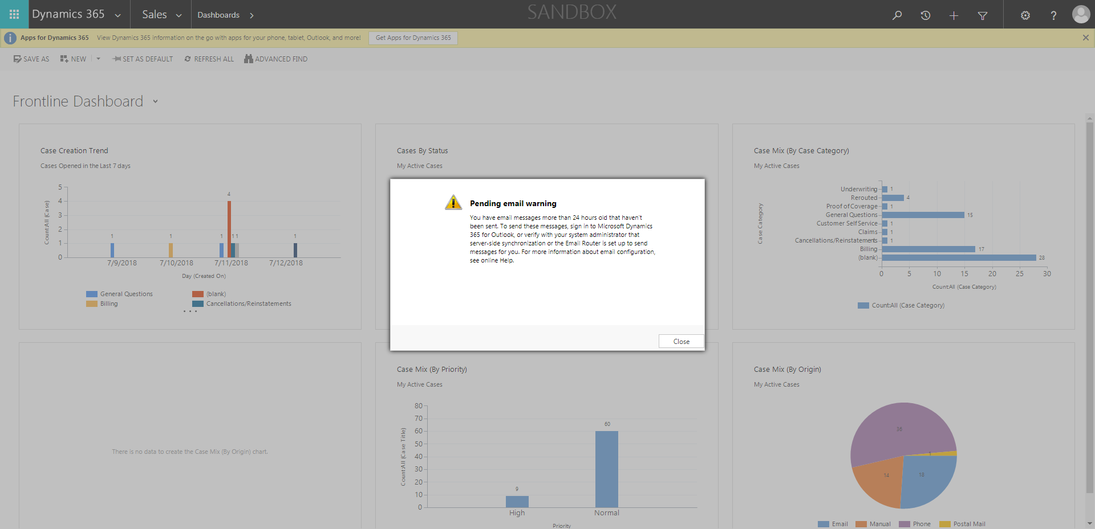

ContactManagement_Verify Contact notes _Instance44_13-Jul-2018_03-37-34_AM_Validatingcontactentitynavigation.png

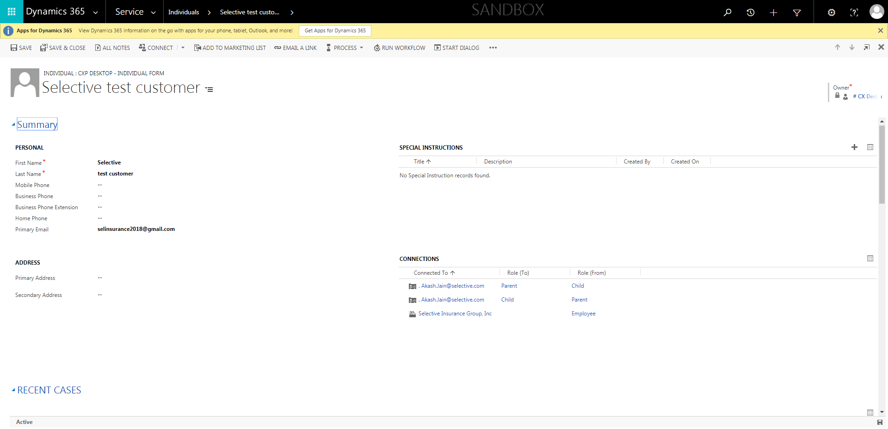

ContactManagement_Verify Contact notes _Instance44_13-Jul-2018_03-36-28_AM_SingleSignOn.png

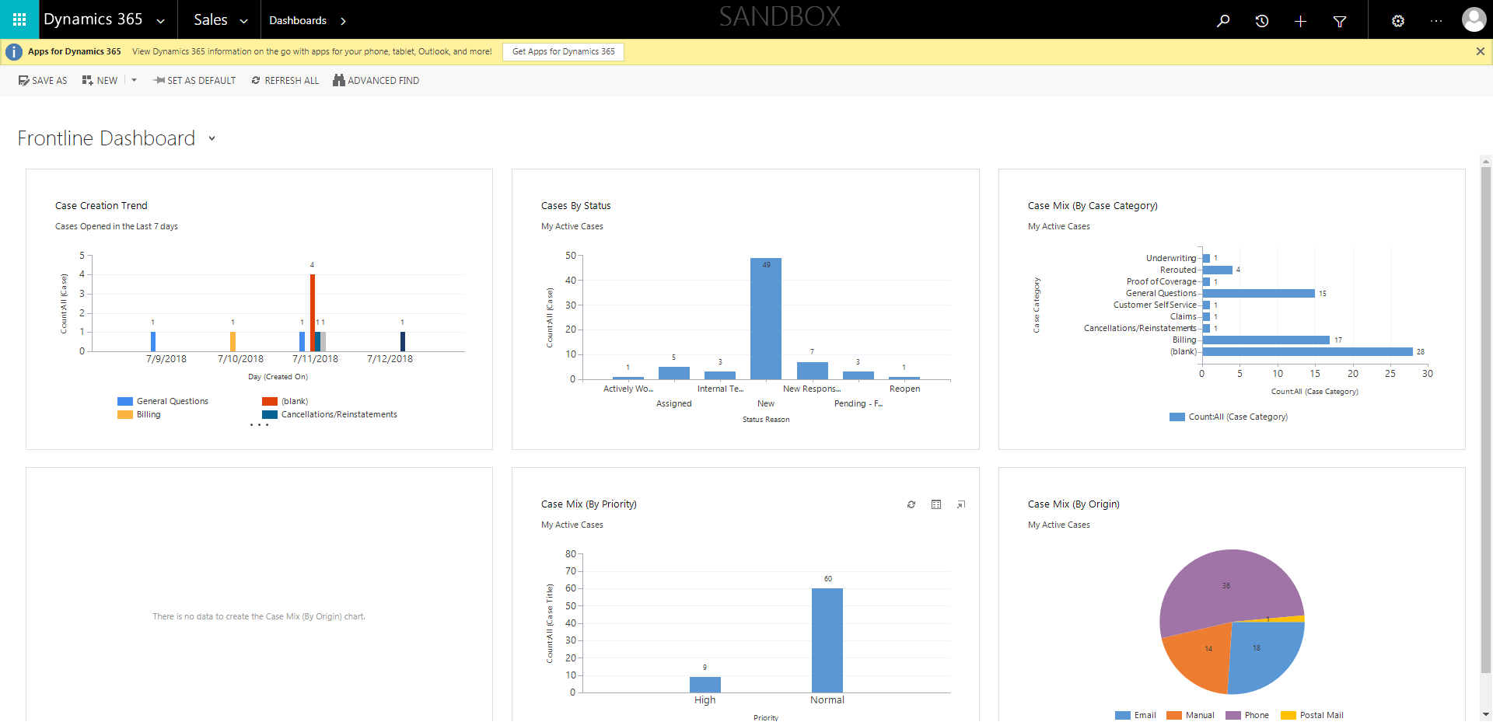

ContactManagement_Verify Contact notes _Instance44_13-Jul-2018_03-38-01_AM_SingleSignOn.png



ContactManagement_Verify Contact notes _Instance44_13-Jul-2018_03-36-08_AM_EnterTextAction.png

